***Quo Vadis*? Career paths of Brazilian regulators**

**ABSTRACT**

**Keywords:** regulators, board members, independent regulatory agencies, careers, revolving door

**INTRODUCTION**

Independent regulatory agencies (IRAs) have proliferated across a wide range of countries and sectors (Levi-Faur and Jordana, 2005; Gilardi et al.2006, Gilardi 2008; Jordana et al. 2011). The diffusion of IRAs found a particularly fertile context in several Latin American countries that have been deeply involved in market-oriented processes since the late 1980s and closely pressured by international organizations such as the World Bank and Organisation for Economic Co-operation and Development (OECD) (Dubash and Morgan 2012; Jacobs 2005; Kirkpatrick et al. 2004; Levi-Faur 2003; Peci XXX). The growth in the number of regulatory institutions in the region, particularly during the 1990s, has been astounding (Gilardi et al. 2006), with Brazil championing the process with more than 60 IRAs created at the federal, state and municipal levels of the government.

Yet, the formal adoption of the IRAs doesn`t necessarily translate in actual independent decision-making in different policymaking domains (Jordana and Ramió 2010; Maggetti 2007). The actual independence of IRAs is commonly associated with a set of expertise and professional requirements for IRA`s board members, that are supposed to guarantee consistency and independent decision-making, despite political cycles. Yet, evidence of revolving door trajectories of regulators in different policy domains fuel regulatory capture theories (see Zheng 2014).

Considering the key role of board members in IRAs decision-making processes, there is broad acceptance that the *de jure* Independence of IRAs is intimately related with the *de facto* independence of IRAs board members (Fernández‐i‐Marín, Jordana and Bianculli, 2016). Understanding the professional trajectories of the regulators, before and after their terms, can shield light on the *de facto* independence of IRAs. Where do the regulators come from, and where do they go after serving their terms in regulatory boards elucidates how the dynamic of regulatory independence enfolds in different policy context and has been focus of relevant research.

Research has focused on prior or post-term trajectories of regulators, considering regulators’ mandates as the starting or the ending point of revolving doors. Studies about the prior experience of the regulators is US and European countries indicate that most of the regulators share prior public sector expertise (Eckert 1981; Fernández‐i‐Marín, Jordana and Bianculli 2016; Spiller 1990). Yet, for regulators moving from the private sector to IRAs boards there is widespread concern that their decision will be market-friendly (Cohen 1986). Additionally, political affiliation of regulators is relevant in different national context (Fernández‐i‐Marín, Jordana and Bianculli 2016;  Ennser-Jedenastik 2016; Thatcher 2005), and some research indicates that might be a stronger predictor of regulatory capture than previous market experience of the regulators (Gromley XXXX). Research about the post-term trajectories of regulators also supports the regulatory capture theories when reveals that, after their terms, most of the regulators with pre-agency jobs in the public sector are rewarded with well-paid jobs in the regulated industry (Eckert, 1981; Spiller, 1990).

By focusing on ex ante or ex post revolving door dynamics, most of the studies assume that prior or post-term professional trajectories of the regulators are separate and independent stages of their professional careers. However, it is reasonable to expect that prior professional career will influence future career paths of regulator, as has been demonstrated in the analysis of the career path of European Union affairs managers (Coen & Vannoni 2016), and in extensive research related to professional careers in general (Abbott and Hrycak, 1990; Abbott and Tsay, 2000; Aisenbrey and Fasang, 2010; Biemann and Datta, 2014; Dlouhy and Biemann, 2015; Gabadinho, Ritschard, Muller& Studer, 2011; Lesnard, 2010; Studer, 2013; Studer and Ritschard, 2016). Career shifts or permanence in the private sector after serving the term in RIAs board may be hampered or potentialized by prior career paths.

Another assumption underlying current research is the absence of barriers in career exchange between the public and private sector. Differently from the US context (Eckert 1981; Spiller 199), in many countries, the entry/exit options in the public service are limited by public exams and rigid rules that may influence career exchange between private and public sector.

Summing up, regulator mandates should not be seen as something exogenous to the rest of their careers, but should be put in a broader career context. Based on these new assumptions, in this paper we rely on career sequence analysis and trace the professional careers of Brazilian regulators, contrasting their previous professional trajectory with the careers paths after serving their terms in regulatory agencies. Our study aims to answer to the following questions: What is the typical career path of a Brazilian regulator? How political affiliation and previous experience in the public or private sector influence their post-term career trajectories? Which of the typical careers gets more salary benefits after serving their terms in IRAs?

Drawing on a sequence analysis of an original data set of XXX Brazilian regulators we uncover five cluster of regulators’ career paths, most of which do not transit between public and private sectors (private or public) after serving their terms. However, we found that career shifts from the public to the private sector were more common for regulators with previous expertise in the public sector, mostly without political affiliations, revealing a “one-way” revolving door professional trajectory. Our research reveals that regulators benefit from serving their terms in IRAs, substantially increasing salaries in most of the clusters, with most expressive gains for regulators with prior private experience that remain in the private sector after serving their terms.

**PROFESSIONAL TRAJECTORIES OF REGULATORS: WHAT DO WE KNOW**

Professional trajectories of regulators have always been of interest to research and contributed to strengthen the outreach of regulatory capture theories. Most of the studies identifies two types of revolving doors dynamics, *ex ante* and *ex post*, indicating that regulators with prospective or previous experience in the regulated sector tend to be more supportive of that sector in their regulatory decisions during the term (Coen & Vannoni 2016).

The dominant perspective privileges the post-term experience of the regulators, focusing on their ex-post performance incentives (Che, 1995; Fox, 1974). These studies contribute to a negative view of regulatory capture by industry interests (Zheng 2014), and are generally corroborated by widely documented revolving door phenomena, defined as the transit from government agencies to the companies they regulate, particularly in the US context (Che 1995). The assumption of regulators guided by narrow, self-interested goals such as post-government personal wealth that exchange regulatory favors to interest groups, such as regulated markets or politicians, dominate the public choice school and are the most notable strand of the capture theories (Stigler 1975; Zheng, 2014), despite controversial research results (Cohen 1986; Gromley 1979; Makkai & Braithwaite 1992). The hypothesis that the expectation of the revolving doors will make the regulator more prone to collude with the firms became popular beyond the academic world.

Most of these studies focus on the “revolving door” revolving from the government to the regulated market, in other words, on the post-term experience after the serving in a government agency. Yet, not all the examples of the revolving door refer to a temporary term served in the government agency, as in the IRAs board members’ mandates we analyze in this research. As a consequence, the revolving door may reflect part of a longer professional trajectories of the regulators, ignoring they previous professional experience before serving the term.

Studies focusing on the prior experience of the regulators before serving the term are also guided by the assumption that a regulator with previous experience in the regulated sector will be more supportive of that sector. However, research indicates that most of the regulators have prior expertise in the public sector, not in the private regulated sector (Eckert, 1981; Fernández‐i‐Marín, Jordana and Bianculli, 2016; Spiller, 1990). For regulators moving from the private industry to IRAs, there is widespread fear that they will be “friendlier” to the market because they have been socialized within the industry (Zheng, 2014). Gormley (1979) observed that prior employment with the broadcasting industry affected the voting patterns of the commissioners at the FCC, but also found that the party affiliation of the commissioners was a better indicator of their voting behavior than their prior industry employment.

As a consequence, the political affiliation of regulators became an interesting variable of their prior experience influencing regulator`s behavior. Additional studies indicate that political affiliation of regulators is expressive in different national context or sectors (Fernández‐i‐Marín, Jordana and Bianculli 2016; Thatcher 2005). Additionally, the politization of board members’ appointees increase with the legal independence of the agencies (Ennser-Jedenastik 2016). In practice, political capture, not previous experience in private regulated markets, might influence regulators’ indications, as commonly expected. Research has shown that regulators with political ties are less sensitive to political changes, and the de facto independence of the regulators increases when they are appointed by the legislature instead of executive direct appointments (Fernández‐i‐Marín, Jordana and Bianculli 2016).

Notwithstanding, the abovementioned theories of regulatory capture based on trajectories are built on several questionable assumptions. To begin with, there is no conclusive evidence that the revolving door leads to regulatory capture during regulators mandates (Cohen 1986; Gromley 1979; Makkai & Braithwaite 1992). Moreover, regulators that come from the public sector may as well adopt market friendly regulations. Incentives that lead to capture are criticized from a human-capital theory that recognizes that regulators might be awarded to a post-term job in the regulated market based on their expertise (Zheng, 2014). Last, but not least, regulators can be captured by other groups of interests, beyond regulated industries, such as bureaucracy or politics (Carpenter and Moss, 2014), but yet capture theories privilege markets as the dominant players in the regulatory arena (Laffont e Tirole, 1991; Peltzman, 1976; Stigler, 1971). Nonrational factors may influence regulatory decision bias, such as the regulators “worldview”, “culture” or social networks (Carpenter and Moss, 2012).

Additionally, the revolving door phenomena are commonly focused on a partial assessment of regulators` professional trajectories: from the government agencies to the market or from the market to the government agencies. Two studies in the north American context take a broader view of regulators professional trajectories, considering their previous and post-term experience (Eckert 1981; Spiller 1990).

Eckert’s (1981) study focused on the pre-commission and post-commission jobs of three regulatory agencies (the Interstate Commerce Commission (ICC), the Civil Aeronautics Board (CAB), and the Federal Communications Commission (FCC)). Firstly, he demonstrated that of 174 appointed regulated, 84 (48%) had some pre-commission experience in the related public sector and only 37 (21%) previously held private sector jobs. In other words, if the commissions have been captured by any interest group, it has been by people from the related public sector. The study also indicates that career shifts from the private to the public sector after serving the term are less commons: only 4% of 34 people who held pre-commission jobs in the related private sector tool post-comission positions in the related public sector; 50% of them returned to private sector position after serving their terms. Secondly, of 142 commissioners, 72 (51%) took private-sector jobs after serving their terms. The study suggests that people with pre-commission experience in the related public sector used their terms as a stepping-stone to jobs in the related private sector, as were also people with previous experience in the related private sector. Better than half eventually took jobs as either attorneys or employees with regulated firms, regardless of the type of pre-commission trajectory

Summing up, the typical career path of regulators consists of a strong performance in the public sector in the run-up to IRA’s direction with a high likelihood of subsequent allocation, either directly or indirectly, to the regulated industry, previously under their jurisdiction, implying that regulators tended to be captured by the companies they regulated. The rewards that regulators can get from serving in IRA’s board, considering they don’t receive high salaries during their terms (the wage is fixed by statute), comes from future gains. The expectation of high-paying jobs in the regulated private sector surpasses the uncertain prospect of re-employment of the position in the board of directors.

Spiller (1988), based on data previously collected by Eckert (1981), analyzed regulators of the same regulatory agencies (e.g: age, term of office, pre-agency and post-agency experience, agency discretionary budget, etc.) considering not just the industry, but also the Congress interest to control the agencies. Spiller’s model recognizes the potential politization of regulators’ appointments. Politicians may reward regulators for favorable outcomes by appointing them to more prestigious positions in the public sector or by increasing the agencies’ budget. Eckert also found that of the 129 regulators, 75% came to the agency with public sector experience and most half left to work directly or indirectly for the regulated industry. While 49 percent of patronage appointments went to work for industry after their terms, only a third of the regulators that came from the private sector did so. The study also revealed that patronage appointments and younger regulators have a higher probability of shifting to a regulated private industry job. Additionally, increases in discretionary budgets of the agencies reduces the probability of going to work for the regulated industry. Other findings refer to a reduced probability of the regulators working for the regulated industry in Republic administrations, and to the impact of an ethic bills that reduced the probability of working for the industry.

Additionally, the “revolving door” phenomena among regulators, when evidenced, contributes to a negative view related to regulatory capture by industry interests (Zheng, 2014), despite controversial research results (Cohen, 1986).

**THE CAREER PATH ANALYSIS OF REGULATORS**

In most of the abovementioned research, entrance and exit in regulatory boards are assumed as static factors that affect the regulators the same way throughout their careers (Cohen, 1986). In fact, early career positions may affect post-term career positions (Abbott and Hrycak, 1990; Abbott and Tsay, 2000; Aisenbrey and Fasang, 2010; Biemann and Datta, 2014; Dlouhy and Biemann, 2015; Gabadinho, Ritschard, Muller& Studer, 2011; Lesnard, 2010; Studer, 2013; Studer and Ritschard, 2016), as Eckert (1981) and Spiller (1988) of US regulators reveal. Considering the career path of a regulator as sequences, that is, successions of standard categorical states or events seems a more plausible approach to understand the professional trajectories of the regulators.

So the first research questions we aim to answer in this study, of an explanatory nature, is: What are the most common career sequences of the Brazilian regulators? Based on this approach, we can further test several career paths, e.g. whether a regulator that has a prior experience in the public sector has a higher probability of shifting to the private regulated sector after serving the term, as Eckert (1981) and Spiller (1988) analysis seems to suggest.

We focused on two characteristics of prior experience that might influence the post-term experience of the regulators: politization and expertise, further asking: Do political affiliation or public sector experience influence the probability of working for the private sector after serving a term in the regulatory board?

Indeed, there is a broad expectation that, prior to their mandates, regulators need to be distinguished by a professional carrier marked by expertise (training and/or work experience) in the regulated sector. In many countries, including Brazil, appointees for serving a mandate in a RIA are required to demonstrate a strong expertise in the regulated sector and, although appointed by the President, need to be formally approved by the legislative. The strong expertise in the regulated sector needs to be demonstrated by the prior professional/training experience, and their CVs are scrutinized in the legislative approval process.

However, as we have seen, studies have already indicated that most of the regulators come from the public sector, and, particularly in the case of Brazil, where utilities state-owned companies preceded privatization reforms. As a consequence, we expect a higher number of regulators to come from the public sector.

Additionally, in many contexts, as in Brazil, the transition from the private to the regulated sector is hampered by a set of legal requirements, such as competitive public exams. As a consequence, the probability of shifting from the private sector to the public sector might be lower than in contexts where such legal requirements do not exist.

As a consequence, our first hypothesis is:

*H1. The probability of working for the private sector after the term is higher for regulators with prior expertise in the public sector than for regulators with prior experience in the private sector.*

An additional requirement relates to regulators apolitical profile, since professionals without political interests would experience less interference in decision making, guaranteeing autonomy (Fernández‐i‐Marín, Jordana and Bianculli, 2016). Indeed, it is expected that regulators with political connections will be diverted from technical and autonomous decision-making. Yet, research has demonstrated that regulators with political ties are less sensitive to political changes (Fernández‐i‐Marín, Jordana and Bianculli 2016), resisting in their terms. How regulators` political affiliations will influence their probability of shifting to a different sector after serving their terms in IRAs?

Based on capture theories, the political affiliation of the regulators indicates they would be captured by politicians (instead of the regulated industry). Based on human-resource theories, the political affiliation of the regulators will overshadow their technical expertise, diminishing the probability of being hired in the private sector after serving their terms. As a consequence, our second hypothesis is:

*H2. The probability of working for the private sector after the term is lower for regulators with political affiliations than for regulators without political affiliations.*

Last, but not least, many of the narratives of post-term experience of the regulators are fueled by the prospective of the increase of salaries in the post-term positions of the regulators.

**Data and measurement**

This study draws on an original dataset consisting of all Brazilian regulators serving in IRAs boards from 1997 (the first agency was created in 1996) to 2018. The regulators served in ten (10) federal regulatory agencies, described in Table 1.

**Table 1: Brazilian Federal Regulatory Agencies**

|  |  |  |  |
| --- | --- | --- | --- |
| ***Agency*** | ***Type of Regulated sector*** | ***Type of Regulation*** | ***Sector*** |
| ANA  National Water Agency | Private and Public | Social - environmental | Hydric resources |
| ANAC  National Civil Aviation Agency | Private and Public | Economic | Civil Aviation, Airports infrastructure |
| ANATEL  National Agency of Telecommunications | Public and Private | Economic | Telecommunications |
| ANCINE  National Cinema Agency | Public and Private | Social (Funding) | Video, phonographic and cinematographic sector |
| ANEEL  National Agency of Electrical Energy | Public and private | Economic | Generation, transmission and distribution of electrical energy |
| ANP  National Agency of Oil and Gas | Public and private | Economic | Oil, gas, and biofuels |
| ANS  National Health Agency | Private | Economic and Social | Private Health Insurance |
| ANTAQ  National Agency of Water Transportation | Public and private | Economic | Water transportation and ports |
| ANTT  National Agency of Transportation | Public and private | Economic | Railways, highways, and railroad infrastructure |
| ANVISA  National Health Surveillance Agency | Public and private | Social | Sanitary surveillance of products, services, ports, airports and borders. |

Source: Peci (2016)

All Brazilian RIAs have a board, composed of 4 to 5 members, that are appointed by the President and go through legislative approval before taking office. Since we focused only on regulators full yearly information about their professional trajectories five years before and five years after the IRAs’ term, the final dataset contains the trajectories of 117 board members.

The main source of expertise data is the Federal Senate of Brazil that scrutinizes the curricula vitae for every director nominated to compose the collegiate board of a federal regulatory agency. These CVs highlight the academic training, level of education and professional experience of professionals. We investigated the political affiliation of board members in the Supreme Electoral Tribunal (TSE) database, which provides a list of affiliates per party in each state of the federation. Data about salaries were extracted from the Annual Social Information Report (RAIS), an official registry of all formal workers in Brazil that indicates employer, occupation according to the Brazilian Classification of Occupations (CBO), compensation and work hours. Finally, we also collected both governmental and non-governmental print (newspapers, magazines) and electronic (websites) media to cover information such as allegations of corruption, legal proceedings, and political scandals.

Table 2 reports individual variables and data sources considered in the research.

Table 1. Study Variables and Data Sources

|  |  |  |
| --- | --- | --- |
| Variables | Definitions | Data Sources |
| Gender | Man or Woman | RAIS |
| Political Affiliation | If the regulator has a political affiliaton in a specific party, registered in each state of the federation and/or holds a legislative, administrative or judicial office (either appointed or elected) | TSE and Senate |
| Academia | If one has a Doctoral or Master of Science degree and/or holds a position in academia | Senate |
| Regulatory Agency | If one is a public servant on behalf of a regulatory agency | Senate |
| Public Service | If one is a public servant on behalf of any government department excluding regulatory agencies | Senate |
| Industry | If one works in the regulated industry | RAIS and Senate |
| Consultancy | If one works as a consultant that provides professional advice related to the regulated industry | RAIS and Senate |

VAMOS AJUSTAR ESTE QUADRO ao que realmente foi utilizado?

**Research design**

Several methods can be used to analyze the careers of the regulators, but we rely on sequence analysis (SA). Sequences are successions of standard categorical states or events, such as evolution of regimes, analysis of speeches, or elections (Blanchard & Fillieule 2011). Professional trajectories also can be seen from a sequence perspective, since careers are a sequence of job positions over time (Spilerman, 1977).

Sequence analysis applies longitudinal data techniques to compare career sequences to map patterns, and has been recently used to analyze European Union affairs managers (Coen & Vannoni 2016). Since the since the 1990s, SA has come to designate a methodological approach with five objectives: a) to describe and to represent sequences, grasping the general trend or pattern in a sample of individuals; b) to compare and classify sequences, inductively observing, what typologies emerge from our sample? What social/ideological factors give it a structure? SA proposes a way to measure the amount of commonality and difference, by means of optimal matching analysis (OMA); c) sequence mining, looking for dominant patterns inside one of the typologies or defining a variable (such as politization, in our case) *a priori*; finally, SA may be used to explain trajectories, searching for the causal relationship between external variables and clusters of similar trajectories that come out of SA (Blanchard & Fillieule 2011).

After running some preliminary tests (not included in the paper, but available under request), we observed only marginal differences between trajectories of men and women, academic or non-academic professionals, regulators or public servants in general and private sector workers or consultants. Thus, only two of seven possible dimensions were taken into consideration: politically affiliated vs. non-affiliated and public vs. private sector.

Our empirical strategy follows three paths. First, we analyzed the data using standard statistical techniques, such as descriptive statistics, contingency tables, mosaic plots and chi-squared tests.

Secondly, we employ Optimal Matching Analysis(OMA), introduced in career analysis by Abbott and Hrycak (1990) and revised by Abbott and Tsay (2000), Aisenbrey and Fasang (2010), and Dlouhy and Biemann (2015). OMA has been widely accepted in career studies. We identified 83 indexed articles articles at *Web of Science* platform, most of them from 2000 and afterwards.[1] Applying OMA to our research problem has a main advantage over *ex ante* classifications due to its flexibility to fit to the data, i.e., it is not necessary to impose any *ex ante* restriction to the grouping of the sequences. The algorithm compares sequences by pairs of states and calculates a distance index based on the replacement of different elements. Shortly, it calculates the distance between two sequences as the cost to transform one into the other by considering the insertion/deletion and substitution of elements (Coen & Vannoni 2016). One must notice that in spite of only two dimensions for each state, there are four possible states for each year, thus in theory there are 1,048,576 (410) possible strings.

Briefly, first OMA defines the distance between sequences as the number of changes needed to transform one string of sequence into another. The lower this "cost," the more similar these sequences are. Second, the operations allowed to transform one sequence into another are the substitution, insertion, and elimination (indel operations) of a given state. The output of the comparison between the strings is a symmetric matrix that displays the distance from one sequence to all others. Finally, this matrix is used to cluster sequences that are more or less similar, even though they are not exactly the same. These groups/clusters are the “ideal-typical” sequences, demonstrating recurrent patterns in the sample (Abbott and Hrycak 1990; Abbott 1991).

In addition, we verified which one of the clusters, which are the ideal-type sequences of regulators` career paths, get more salary increases in post-term positions.

Finally, we tested explicitly through a binary choice model if political affiliation or previous experience in the public sector influences the probability of working for the private sector after a term in the regulatory board. This simple two-dimension classification proved to be very useful to understand’ the changes from public to private sector or vice versa, and how political affiliation helps or hampers these transitions.

**DESCRIPTIVE ANALYSIS OF STRINGS**

We begin by showing some descriptive statistics, analyzed with the The TraMineR package (Gabadinho et al. 2011). In spite of the high number or possibilities, in practice there are only 27 strings that illustrate the career paths of the Brazilian regulators. The reason for that is the low rate of transitions from one state to the other during the first or last five years of the sequence. When transitions take place, they tend to do before-and-after the term in the regulatory board. This stability may be observed in the tempogram (Figure 1), where the 0 point refers to the term in the board of the IRA.

Figure 1. Tempogram of the sequences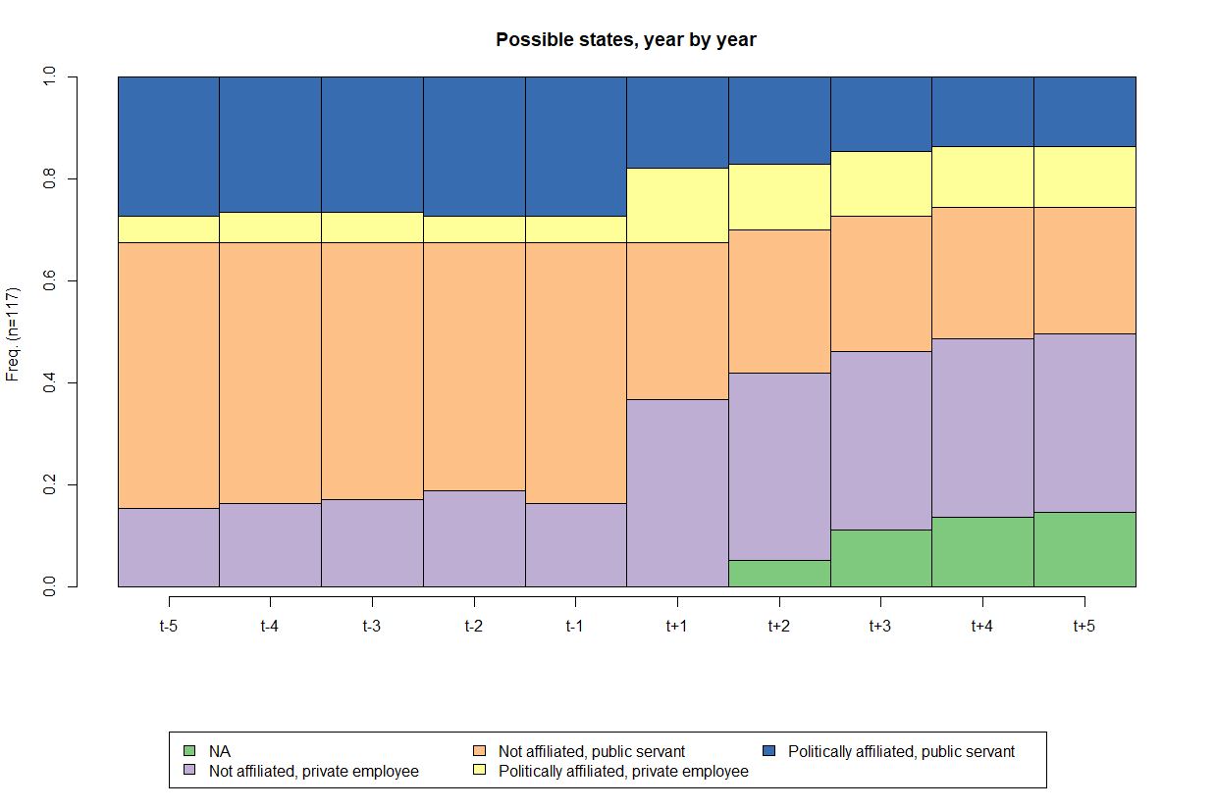

As a result of the low number of observed sequences, ten most common ones correspond to 84.6% of occurrences, as displayed in Figure 2.

Figure 2. Ten most common sequences

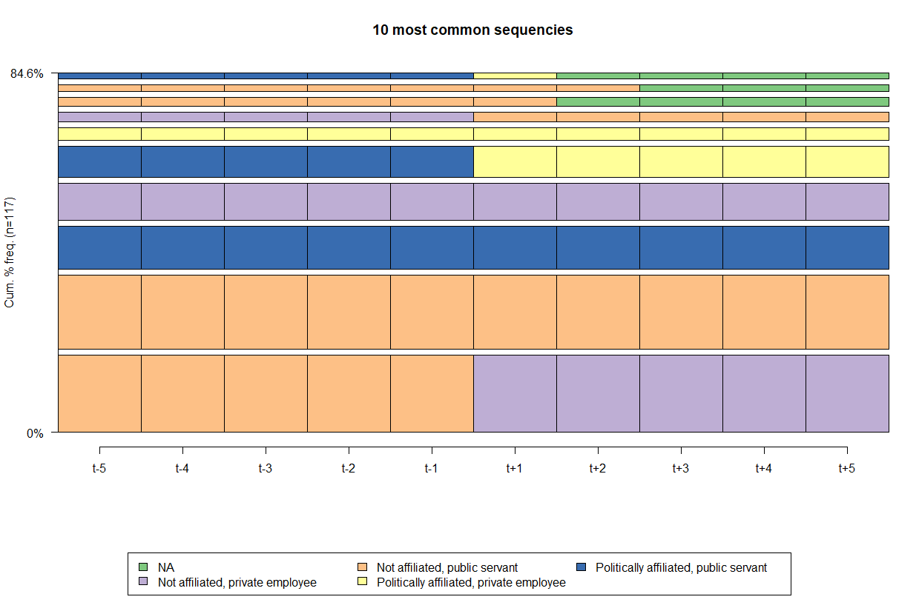

Some preliminary findings can be drawn from Fig.2. First, we can see that the most frequent pre-term occupation is in the public sector, as other studies suggest (Eckert 1981). The number of private employees in the pre-term occupation is low, but increases in the post-terms occupations.

The most frequent string illustrates public servants, without political affiliation, that move to the private sector or become consultants in the regulated industry after serving their term (25 occurrences). The second string shows public servants, without political affiliation, that remain in the public service after term (24). The third string represents public servants, with political affiliation, that remain in the public service after term (14). The fourth string refers to private employees, without political affiliation, who tend to go back to the regulated private sector (12). The fifth sequence shows public servants, with political affiliation, that are hired by the private sector after term (10). Next, private employees, with political affiliation, remain in the regulated private sector (4).

From this simple descriptive analysis, one may infer that politically affiliated regulators do not change their positions, i.e., having political affiliation is not a post-term gain. Neither it precludes of being appointed, nor it guarantees any position post-term. Indeed, most of private sector workers in the after-term come from the public sector, but they are not politically affiliated.

A chi-squared test, a contingency table (Table 3) and a mosaic plot (Fig 3) reveal whether there is some trajectory bias that can be attributed to IRAs. Indeed, the overall chi-squared test rejects the null hypothesis of no bias towards any IRA, at less than 0.001% of significance. A contingency table and a mosaic plot point out the sources of these biases, through the difference between observed (first line of each cell), expected (second line) and their respective standardized residuals (third line). Standardized residuals may be interpreted as ordinary t-statistic observed values.

Hence, according to standard confidence levels (10%, 5% and 1% for rejection of the null hypothesis), only two cells show significant differences between observed and expected values, and both refer to agencies of transportation. ANAC (the aviation agency) has a larger-than-expected proportion of regulators coming from the private sector (and eventually returning to private jobs), and ANTAQ (the waterway transportation Agency) has the same for politically affiliated public servants, who tend to return to the public service after their terms. Can we conclude that these two agencies follow different patterns than the rest? Anac seems to be more “captured” by private interest, while Anac from politicians?

Table 3. Types of trajectories per agency

|  |  |  |  |  |  |  |
| --- | --- | --- | --- | --- | --- | --- |
| IRA | Others | Always private, not affilliated | Always public, affilliated | Always public, not affilliated | Public to private, affilliated | Public to private, not affilliated |
| ANP | 3  3.06  (-0.04) | 2  1.15  (0.88) | 2  2.2  (-0.16) | 2  0.96  (1.17) | 1  2.3  (-1.01) | 1  1.34  (-0.33) |
| ANAC | 4  3.9  (0.07) | 4  1.46  (2.37) | 1  2.8  (-1.28) | 1  1.22  (-0.22) | 3  2.92  (0.05) | 1  1.7  (-0.61) |
| ANATEL | 4  4.45  (-0.27) | 1  1.67  (-0.59) | 4  3.2  (0.54) | 2  1.39  (0.58) | 3  3.34  (-0.22) | 2  1.95  (0.04) |
| ANCINE | 3  2.78  (0.16) | 1  1.04  (-0.05) | 1  2  (-0.83) | 1  0.87  (0.15) | 2  2.09  (-0.07) | 2  1.22  (0.79) |
| ANEEL | 5  4.17  (0.51) | 0  1.57  (-1.42) | 5  3  (1.38) | 1  1.3  (-0.3) | 2  3.13  (-0.77) | 2  1.83  (0.15) |
| ANS | 5  4.45  (0.33) | 3  1.67  (1.17) | 3  3.2  (-0.13) | 0  1.39  (-1.33) | 3  3.34  (-0.22) | 2  1.95  (0.04) |
| ANTAQ | 1  1.95  (-0.82) | 0  0.73  (-0.93) | 4  1.4  (2.54) | 0  0.61  (-0.84) | 1  1.46  (-0.44) | 1  0.85  (0.18) |
| ANTT | 2  2.23  (-0.18) | 0  0.83  (-1) | 2  1.6  (0.37) | 1  0.7  (0.4) | 3  1.67  (1.2) | 0  0.97  (-1.09) |
| ANVISA | 3  3.06  (-0.04) | 0  1.15  (-1.19) | 1  2.2  (-0.95) | 1  0.96  (0.05) | 4  2.3  (1.33) | 2  1.34  (0.64) |
| ANA | 2  1.95  (0.05) | 1  0.73  (0.34) | 0  1.4  (-1.37) | 1  0.61  (0.54) | 2  1.46  (0.52) | 1  0.85  (0.18) |

Note: observed and expected values in the first two lines, and standardized difference between parentheses.

Figure 3. Mosaic plot: Types of trajectories per agency

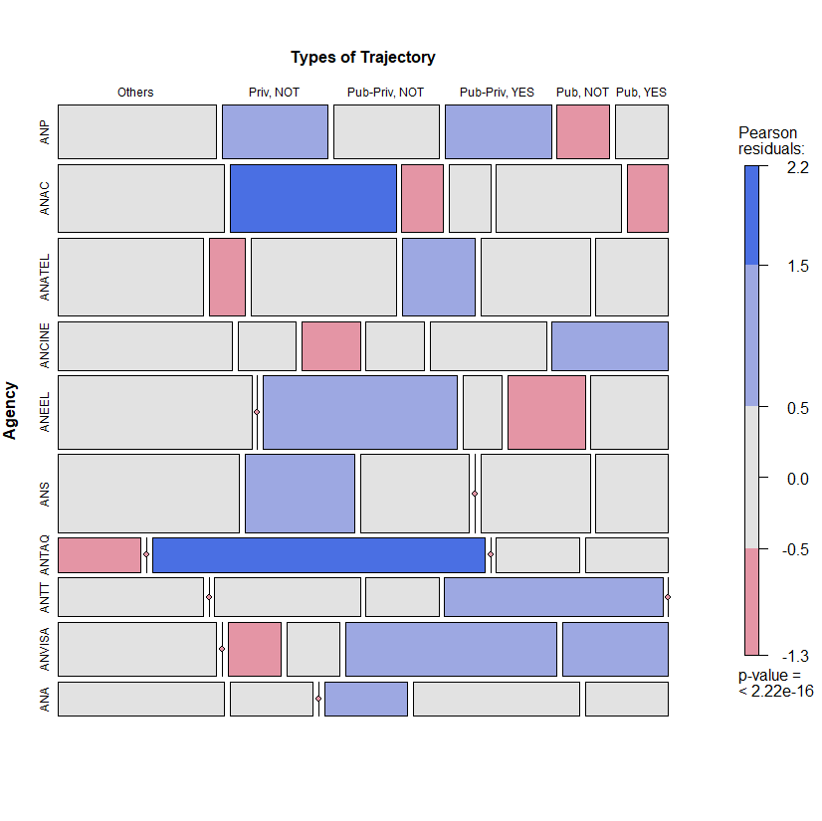

**Podemos incluir aqui a parte dos 20 que interromperam o mandato. E destacar o papel da Anac neste sentido tmb.**

**OPTIMAL MATCHING ANALYSIS (OMA): THE CAREER PATH ANALYSIS OF BRAZILIAN REGULATORS**

As in other analysis, we relied on Optimal Matching Analysis (OMA) to understand the Besides the coding of sequences and the time frame, there are two critical decisions in applying OMA: the deletion/insertion and replacement costs between the states, when applicable; and the criterion for grouping the sequences. Simulations were conducted using the R statistical programming language. The TraMineR package was used for the sequence analysis, as described by Gabadinho et al. (2011). The TraMineR algorithm is essentially that of Needleman and Wunsch, with standard optimizations (Gabadinho et al., 2011).

The transition costs between states follow the transition probabilities. This choice has been a growing trend in the literature (Aisenbrey and Fasang, 2010; Dlouhy and Biemann, 2015). Mathematically, the transition cost from state *i* to state *j* (*i ≠ j*) is equal to 2 – *p(i|j) – p (j|i)*, where *p(i|j)* is the transition rate between states *i* and *j* in the sample. The rationale behind this approach is that the transitions observed more frequently are less costly than less frequent transitions. By definition, the probability of a transition from one state to itself is equal to one, which makes the transition cost zero.

The clustering method was Ward’s hierarchical cluster, a standard in the literature. The choice of the number of clusters involved the analysis of some measures available in the R cluster package of and visual dendrogram inspection. No definitive criterion to choose the number of clusters exists; some methods and indicators aid researchers in this decision, but they often do not point towards a single solution. Some criteria for this choice are presented in Figure 5. Herein, we chose a five-fold solution, based on the dendrogram (Fig 4) and the analytical power of such a solution compared to alternatives. All code used to conduct the simulations and generate plots, as well as the simulation results presented herein, are available upon request.

AS tres figuras que aparecem aqui uma atras das outras precisam ter um paragrafo introdutorio. Nao e comum ver tantas figuras juntas, sem uma explicacao sobre o papel de cada uma delas. Então sugiro dividir o paragrafo acima em partes que aparecer antes de cada figura.

Figure 4. Dendogram of OMA: 5 cluster solution

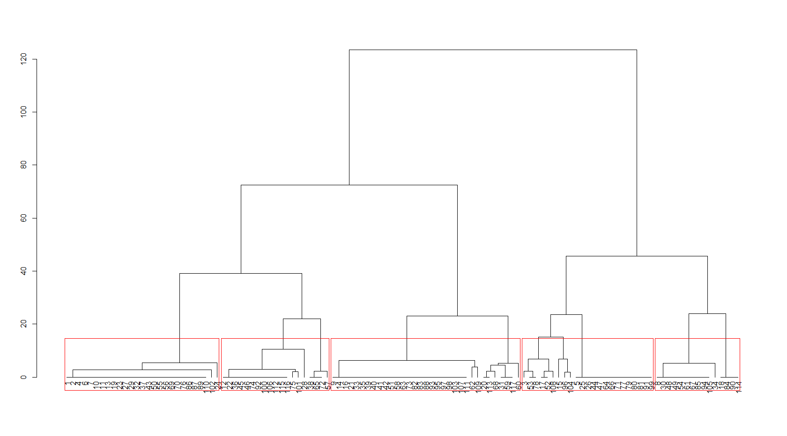

Figure 5. Some indicators regarding the number of Clusters: CH, Silhouette and Elbow Graphs

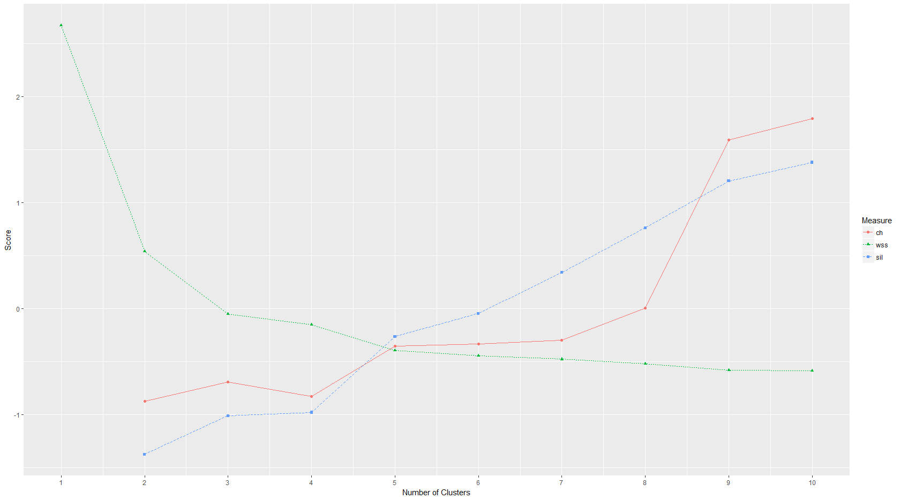

Figure 6. Tempogram: 5 cluster solution

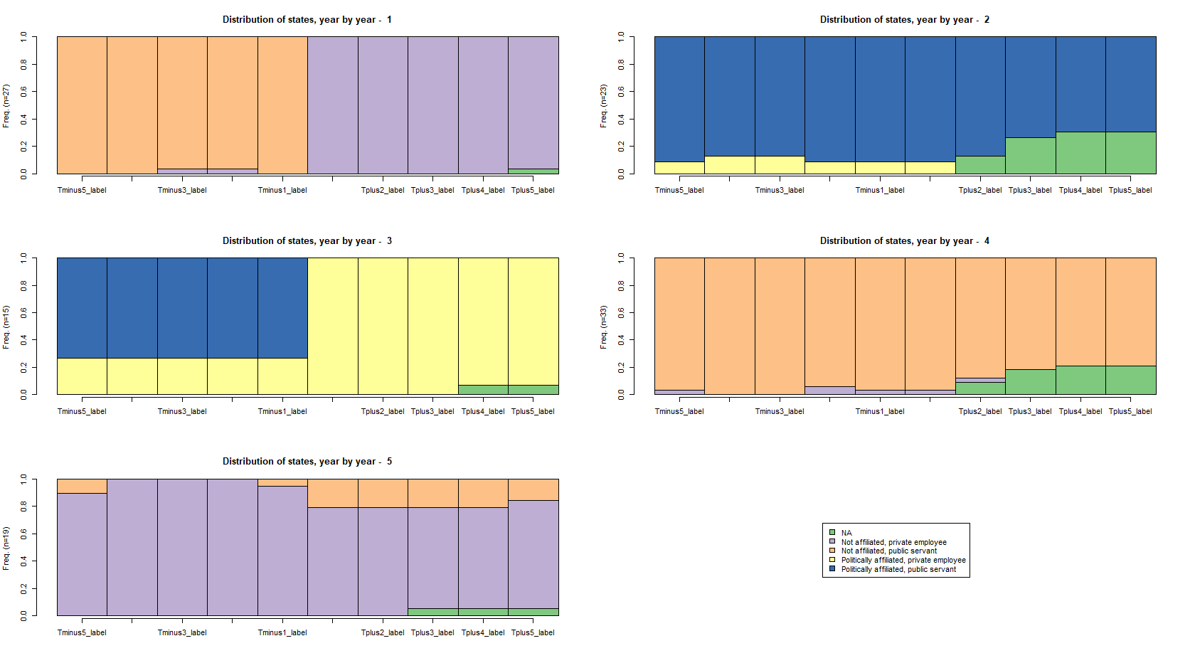

Not surprisingly, the five-cluster solution is very close to the previously presented in the descriptive analysis? :

* Cluster 1 (n=27) - public servants, not affiliated, who then become private sector non-affiliated workers;
* Cluster 2 (n=23) – politically affiliated public servants, who return to their positions after their terms as regulators;
* Cluster 3 (n=15) - politically affiliated public servants, who manage to go to the private sector afterwards;
* Cluster 4 (n=33) – not politically affiliated public servants, who return to their positions after their terms;
* Cluster 5 (n=19) – not affiliated private workers.

Figure 7. The most common sequences, 5 cluster solution

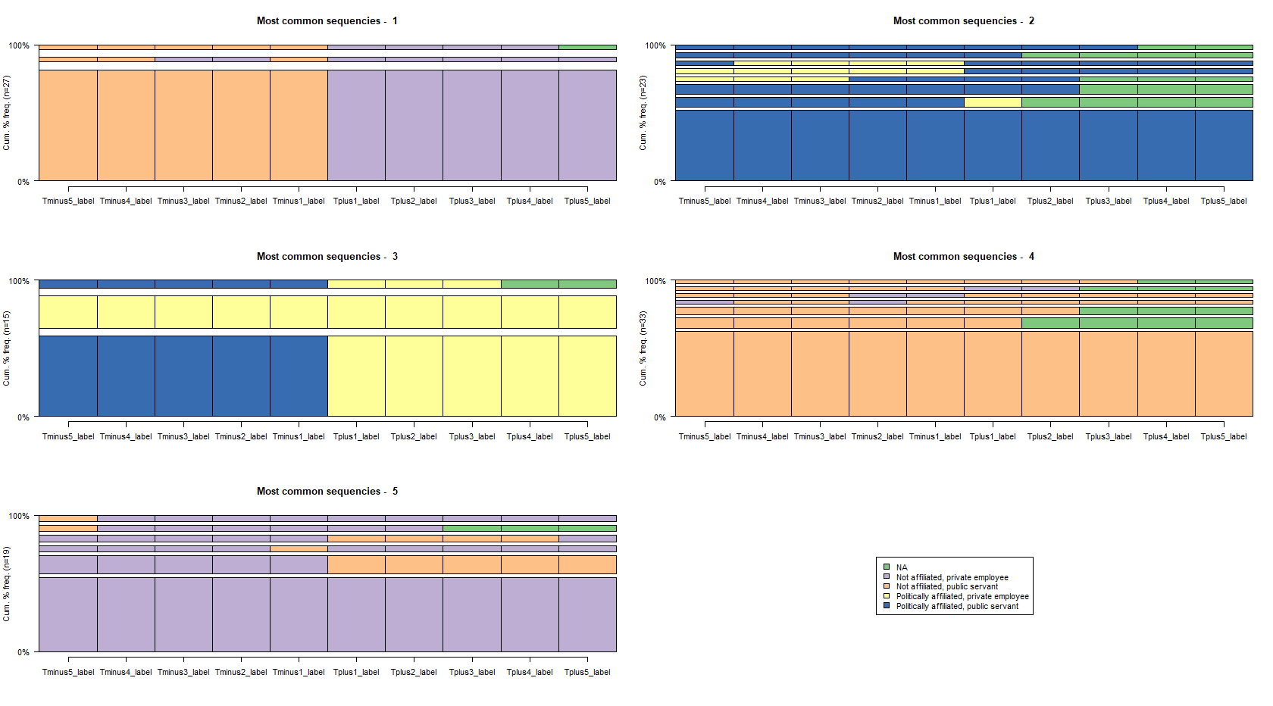

Table 4 brings the communality between the categories, the “hard” one and that from OMA. The “others” cell from the hard categorization is distributed among the five-fold categories that emerge from the OMA. All other categories show a 100% communality when one compares the equivalent cells from the hard categorization and OMA.

Table 4. Comparison between the “hard” classification and OMA

|  |  |  |  |  |  |
| --- | --- | --- | --- | --- | --- |
|  | Always private, not affiliated | Always public, affilliated | Always public, not affiliated | Public to private, affiliated | Public to private, not affiliated |
| Others | 7 | 9 | 9 | 5 | 2 |
| Always private, not affilliated | 12 | 0 | 0 | 0 | 0 |
| Always public, affilliated | 0 | 14 | 0 | 0 | 0 |
| Always public, not affilliated | 0 | 0 | 24 | 0 | 0 |
| Public to private, affilliated | 0 | 0 | 0 | 10 | 0 |
| Public to private, not affilliated | 0 | 0 | 0 | 0 | 25 |

**Politization and publicization of regulators careers: what matters more?**

In this section, we test explicitly the hypothesis whether having previous experience in the public sector helps or hampers an afterwards career in the private sector. We do the same for political affiliation of the regulators.

The first *probit* model is in table 5. Being a former public servant raises the probability of working in the private sector afterwards. In fact, former public servants have 2.75 more chances to work at the private sector than former private workers do. Politics seems not to affect the after-agency pattern, since one cannot reject the null hypothesis that its coefficient is zero.

Table 5. Probit model (dependent variable: at the private sector after a term as a regulator)

|  |  |  |  |  |
| --- | --- | --- | --- | --- |
|  | Estimate | Std. Error | z value | Pr(>|z|) |
| (Intercept) | -0.975** | 0.464 | -2.103 | 0.036 |
| **Previously in public sector** | **1.012\*\*** | **0.497** | **2.038** | **0.042** |
| Politically affiliated | 0.333 | 0.404 | 0.824 | 0.410 |
| AIC | 162.69 |  |  |  |
| DF | 114 |  |  |  |

* - significant at 5%

We also a run a second model restricted to those former public servants. The underlying hypothesis is that political affiliation may have differentiated effects in the odds of getting a private position depending if the regulator comes from the public or private sector. Results are in table 6.

Table 6. Probit model, restricted to public servants (dependent variable: at the private sector after a term as a regulator)

|  |  |  |  |  |
| --- | --- | --- | --- | --- |
|  | Estimate | Std. Error | z value | Pr(>|z|) |
| (Intercept) | 0,033 | 0,256 | 0,128 | 0,898 |
| Politically affiliated | 0,347 | 0,442 | 0,785 | 0,433 |
| AIC | 131.72 |  |  |  |
| DF | 92 |  |  |  |

From this model, one cannot reject the null hypothesis that political affiliation has no impact on the probability of working at the private sector after a term in a regulatory board.

**Salary benefits**

Last, but not least, we verified which of the clusters get more salary benefits after serving their mandates in IRAs. Figure 7 depicts the before-and-after wages of IRA board members. Perhaps surprisingly, former public servants seem to earn *less* in the private sector after their terms as regulators, at least the non-affiliated ones. However, this might be related to the fact that most of former public servants are not hired directly in regulated companies, but work as consultants, many in their owned companies. WE need to support data on that, verificar ONDE estao estes caras de forma qualitative.

The cluster that gets more salary benefits after the term is that of non-affiliated private sector regulators who return to the private sector after their mandates. Many of these regulators use the IRA mandate as a form of potentializing their benefits. However, one should notice that they are rather few: 25 out of 117 trajectories. Moreover, we did not run a formal test for wage premia derived by the experience in the IRA. It means there’s nothing to be said, at least from figure 7, regarding whether or not former members of IRA boards earn more or less than their counterfactuals due to their status as IRA board members.

Figure 7. Wages by professional trajectory, 5 years before and after a mandate at IRA

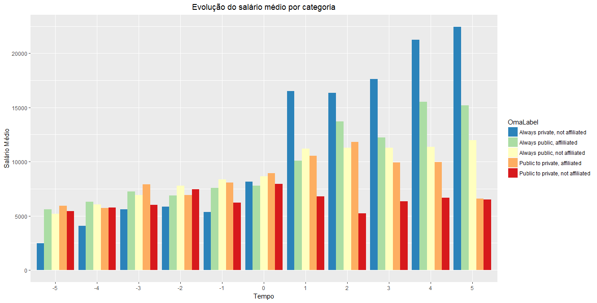

**Tmb nao deveriamos falar aqui que todos os clusters tiveram aumento post term?**

**CONCLUSION**

* In terms of pre-term experience Brazilian regulators are captures by the public sector. Explain possible why/compare with other experiences
* Private sector has a more modest role (but a growing one)
* Clusters of regulators indicate a one-way career path for former public servants, most of them without political affiliation, shifting sector after serving the mandates. Why. Corroborates human-capital theories. But also the expanding the market (if we prove many opened/worked for their own companies).
* There are some differences in agencies related to transportation. Explain possible whys.

This study evidenced that most regulators come from the public sector, contributing to the literature that focus on regulatory capture based on the analysis of professional trajectories. No less than 77 of 117 strings under analysis begin their professional trajectories in the public sector. Hence, the public sector is surely a “talent pool” for recruiting IRA board members. Most of former public servants tend to return to the public sector after their mandates.

Reversely, only 40 members of IRA boards come from the private sector. Indeed, most of post-mandate private sector workers come from the public sector. From 48 regulators that work at the private sector after their mandates, almost a half (25) are former public servants. The 25 regulators - originally private sector workers that manage to return to the private sector afterwards – tend to be the best paid workers, but we can not infer causality because we did not run a formal test for wage premia between the categories. In any case, revolving door trajectories are not the most common in Brazilian IRAs.

Public servants are probably chosen for IRA’s boards due to their specific experience – according to a human capital perspective – or even because the manage to expand the “market” for their skills – according to market expansion theory (Zheng, 2014). This theory focuses on the incentive for regulators to expand the market demand for services they would be providing when they exit the government. “Regulocrats” make rules broad enough and complex enough to require expertise in interpretation/implementation. However, whether this is a rational calculus or reflects the expansion of bureaucratic culture is an open question.

Finally, future research should confront the professional trajectories with some measure of regulatory quality, or even capture. However, we believe that this kind of study should be eminently of qualitative nature.

REFERENCES

Abbott, A., & Hrycak, A. (1990). Measuring resemblance in sequence data: An optimal matching analysis of musicians' careers. American journal of sociology, 96(1), 144-185.

Abbott, A., & Tsay, A. (2000). Sequence analysis and optimal matching methods in sociology: Review and prospect. Sociological methods & research, 29(1), 3-33.

Aisenbrey, S., & Fasang, A. E. (2010). New life for old ideas: The" second wave" of sequence analysis bringing the" course" back into the life course. Sociological methods & research, 38(3), 420-462.

Beblavy, M. (2011). Understanding the waves of agencification and the governance problems they have raised in central and eastern european countries.

Biemann, T., & Datta, D. K. (2014). Analyzing sequence data: Optimal matching in management research. Organizational Research Methods, 17(1), 51-76.

Carpenter, D. and Moss, D. A. (2013). Preventing regulatory capture: Special interest influence and how to limit it. Cambridge University Press.

Cavalcanti, B. S. and Peci, A. (2001). Para uma leitura política do ambiente regulatório brasileiro: Agências reguladoras e relações com os principais atores políticos.

Christensen, T. and Lægreid, P. (2005). Regulatory reforms and agencification. Cohen, J. E. (1986). The Dynamics of the" Revolving Door" on the FCC. *American Journal of Political Science*, 689-708.

Dlouhy, K., & Biemann, T. (2015). Optimal matching analysis in career research: A review and some best-practice recommendations. Journal of Vocational Behavior, 90, 163-173.

Eckert, R. D. (1981). The life cycle of regulatory commissioners. The Journal of Law and Economics, 24(1):113–120.

Gabadinho, A., Ritschard, G., Mueller, N. S., & Studer, M. (2011). Analyzing and visualizing state sequences in R with TraMineR. Journal of Statistical Software, 40(4), 1-37.

Gilardi, F. (2002). Policy credibility and delegation to independent regulatory agencies: a comparative empirical analysis. Journal of European Public Policy, 9(6):873–893.

Fernández‐i‐Marín, X., Jordana, J., & Bianculli, A. C. (2016). Are regulatory agencies independent in practice? Evidence from board members in Spain. *Regulation & Governance*, 10(3), 230-247.

Jordana, J., Levi-Faur, D., and i Marín, X. F. (2011). The global diffusion of regulatory agencies: channels of transfer and stages of diffusion. Comparative political studies, 44(10):1343–1369.

Jordana J, Ramió C (2010) Delegation, Presidential Regimes, and Latin American Regulatory Agencies. *Journal of Politics in Latin*  *America* 2(1), 3–30.

Justen Filho, M. (2006). Agências reguladoras e democracia: existe um déficit democrático na “regulação independente?”. O poder normativo das agências reguladoras, Alexandre Santos de Aragão (Coordenador)...[et al]. Rio de Janeiro: Forense.

Lesnard, L. (2010). Setting cost in optimal matching to uncover contemporaneous socio-temporal patterns. Sociological Methods & Research, 38(3), 389-419.

Makkai, T., & Braithwaite, J. (1992). In and out of the revolving door: Making sense of regulatory capture. *Journal of Public Policy*, *12*(1), 61-78.

Maggetti M (2007) De Facto Independence after Delegation: A Fuzzy-set Analysis. *Regulation & Governance* 1, 271–294.

Meirelles, F. and Oliva, R. (2006). Delegation and political control of the regulatory agencies in brazil. Revista de Administração Pública, 40(4):545–565.

Nunes, A. J. A. (2007). Breve reflexão sobre o chamado estado regulador. Sequência: Estudos Jurídicos e Políticos, 28(54):9–18.

Peci, A. Regulatory Reform and a Better Regulation Agenda: Traveling from Center to Periphery. In: Klassen, T. R., Cepiku, D., & Lah, T. J. (Eds.). (2016). *The routledge handbook of global public policy and administration*. Taylor & Francis.

Schrefler, L. (2010). The usage of scientific knowledge by independent regulatory agencies. Governance, 23(2):309–330.

Shapiro, M. (2002). Judicial delegation doctrines: the us, britain, and france. West European Politics, 25(1):173–199.

Spiller, P. T. (1990). Politicians, interest groups, and regulators: A multiple-principals agency theory of regulation, or” let them be bribed”. The Journal of Law and Economics, 33(1):65–101.

Stigler, G. J. (1975). *The citizen and the state: Essays on regulation* (Vol. 720). Chicago: University of Chicago Press.

Studer, M. (2013). WeightedCluster library manual: A practical guide to creating typologies of trajectories in the social sciences with R.

Studer, M., & Ritschard, G. (2016). What matters in differences between life trajectories: A comparative review of sequence dissimilarity measures. Journal of the Royal Statistical Society: Series A (Statistics in Society), 179(2), 481-511.

Thatcher M (2005) The Third Force? Independent Regulatory Agencies and Elected Politicians in Europe. *Governance: An International Journal of Policy, Administration and Institutions* 18, 347–373.

Zheng, W. (2014). The revolving door. *Notre Dame L. Rev.*, *90*, 1265.

Wu, I. (2008). Who regulates phones, television, and the internet? What makes a communications regulator independent and why it matters. Perspectives on politics, 6(4):769– 783.

1. According to a search in June 2019, without quotes and in the “topics” field.